Experiment – 18
Implement Perceptron based IRIS classification.

Aim:
To classify different types of data using the Perceptron classification algorithm and predict the class of new samples for five given datasets.

Algorithm:
- Import the required Python libraries.
- Create the five given datasets.
- Separate each dataset into input features X and target labels y.
- Split the data into training and testing sets.
- Create a Perceptron classifier.
- Train the Perceptron model using the training data.
- Predict the classes of the test data.
- Calculate the classification accuracy.
- Predict the class of the given new sample.
- Display the accuracy and predicted class for all five datasets.

Program:
import numpy as np
import pandas as pd
from sklearn.tree import DecisionTreeClassifier
from sklearn.neighbors import KNeighborsClassifier
from sklearn.model_selection import train_test_split
from sklearn.metrics import accuracy_score
def compare_models(name, X, y, new_sample):
print("\n" + "=" * 65)
print(name)
print("=" * 65)
# Step 2: Split dataset into training and testing data
X_train, X_test, y_train, y_test = train_test_split(
X,
y,
test_size=0.3,
random_state=42,
stratify=y
)
dt_model = DecisionTreeClassifier(random_state=42)
dt_model.fit(X_train, y_train)
knn_model = KNeighborsClassifier(n_neighbors=3)
knn_model.fit(X_train, y_train)

# Step 5: Predictions on test data
dt_predictions = dt_model.predict(X_test)
knn_predictions = knn_model.predict(X_test)

# Step 6: Calculate accuracy
dt_accuracy = accuracy_score(y_test, dt_predictions)
knn_accuracy = accuracy_score(y_test, knn_predictions)

# Step 7: Predict new sample
dt_new_prediction = dt_model.predict(new_sample)[0]
knn_new_prediction = knn_model.predict(new_sample)[0]

# Display results
print("Test Samples:", len(y_test))

print("\nDecision Tree Accuracy:",
round(dt_accuracy * 100, 2), "%")

print("KNN Accuracy:",
round(knn_accuracy * 100, 2), "%")

print("\nNew Sample Prediction:")
print("Decision Tree:", dt_new_prediction)
print("KNN:", knn_new_prediction)

# Compare algorithms
if dt_accuracy > knn_accuracy:
print("\nBetter Algorithm: Decision Tree")

elif knn_accuracy > dt_accuracy:
print("\nBetter Algorithm: KNN")

else:
print("\nBetter Algorithm: Both have the same accuracy")

return dt_accuracy, knn_accuracy
# ============================================================
# DATASET 1: STUDENT PLACEMENT PREDICTION
# ============================================================
X1 = np.array([
[9.2, 90, 88],
[8.8, 85, 82],
[8.5, 80, 79],
[7.2, 72, 70],
[6.8, 68, 65],
[9.0, 92, 90],
[7.5, 75, 74],
[8.6, 84, 81],
[6.5, 60, 58],
[8.9, 88, 86]
])

y1 = np.array([
"Placed",
"Placed",
"Placed",
"Not Placed",
"Not Placed",
"Placed",
"Not Placed",
"Placed",
"Not Placed",
"Placed"
])

new1 = np.array([[8.7, 86, 84]])

result1 = compare_models(
"DATASET 1: STUDENT PLACEMENT PREDICTION",
X1, y1, new1

# ============================================================
# DATASET 2: LOAN APPROVAL PREDICTION
# ============================================================
X2 = np.array([
[8, 780, 5],
[7, 760, 4],
[6, 730, 5],
[4, 620, 8],
[3, 590, 9],
[9, 810, 4],
[5, 650, 7],
[8, 770, 5],
[4, 610, 8],
[7, 750, 6]
])

y2 = np.array([
"Approved",
"Approved",
"Approved",
"Rejected",
"Rejected",
"Approved",
"Rejected",
"Approved",
"Rejected",
"Approved"
])

new2 = np.array([[7, 760, 5]])

result2 = compare_models(
"DATASET 2: LOAN APPROVAL PREDICTION",
X2, y2, new2
)
# ============================================================
# DATASET 3: DISEASE DIAGNOSIS
# ============================================================
X3 = np.array([
[39.0, 110, 94],
[38.5, 108, 95],
[37.0, 78, 99],
[39.2, 115, 93],
[36.8, 75, 98],
[38.8, 112, 94],
[37.2, 80, 98],
[39.1, 114, 92],
[36.7, 74, 99],
[38.9, 111, 93]
])
y3 = np.array([
"Positive",
"Positive",
"Negative",
"Positive",
"Negative",
"Positive",
"Negative",
"Positive",
"Negative",
"Positive"
])
new3 = np.array([[38.7, 109, 94]])
result3 = compare_models(
"DATASET 3: DISEASE DIAGNOSIS",
X3, y3, new3
)
# ============================================================
# DATASET 4: EMPLOYEE PROMOTION PREDICTION
# ============================================================
X4 = np.array([
[10, 95, 50],
[8, 90, 45],
[7, 88, 40],
[3, 65, 20],
[2, 60, 18],
[9, 93, 48],
[4, 70, 25],
[8, 89, 42],
[2, 58, 15],
[6, 85, 38]
])

y4 = np.array([
"Promoted",
"Promoted",
"Promoted",
"Not Promoted",
"Not Promoted",
"Promoted",
"Not Promoted",
"Promoted",
"Not Promoted",
"Promoted"
])
new4 = np.array([[7, 90, 44]])
result4 = compare_models(
"DATASET 4: EMPLOYEE PROMOTION PREDICTION",
X4, y4, new4
)
X5 = np.array([
[100, 95, 70],
[125, 110, 65],
[150, 125, 55],
[800, 850, 22],
[1000, 950, 20],
[1200, 1050, 18],
[110, 100, 68],
[900, 900, 21],
[140, 120, 58],
[1300, 1100, 17]
])

y5 = np.array([
"Bike",
"Bike",
"Bike",
"Car",
"Car",
"Car",
"Bike",
"Car",
"Bike",
"Car"
])

new5 = np.array([[135, 118, 60]])

result5 = compare_models(
"DATASET 5: VEHICLE CLASSIFICATION",
X5, y5, new5
)

# ============================================================
# FINAL COMPARISON TABLE
# ============================================================

results = pd.DataFrame({
"Dataset": [
"Student Placement",
"Loan Approval",
"Disease Diagnosis",
"Employee Promotion",
"Vehicle Classification"
],
"Decision Tree Accuracy (%)": [
result1[0] * 100,
result2[0] * 100,
result3[0] * 100,
result4[0] * 100,
result5[0] * 100
],
"KNN Accuracy (%)": [
result1[1] * 100,
result2[1] * 100,
result3[1] * 100,
result4[1] * 100,
result5[1] * 100
]
})

print("\n\n")
print("=" * 65)
print("FINAL ACCURACY COMPARISON")
print("=" * 65)

print(results.to_string(index=False))
Output:
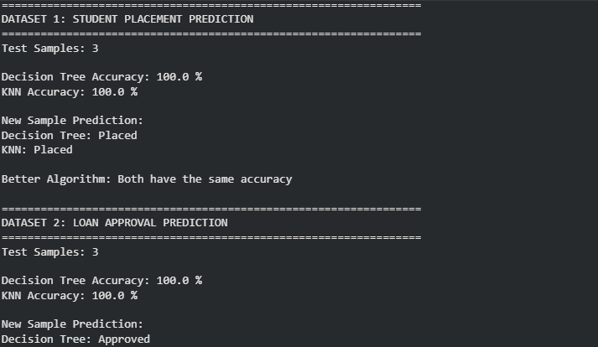
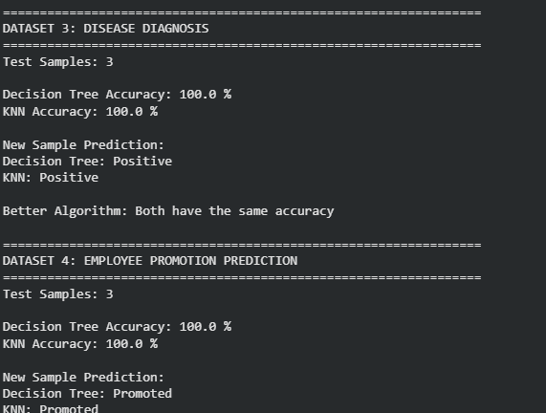

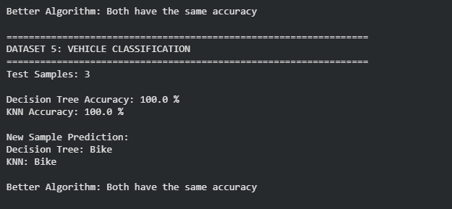

Result:
The Perceptron algorithm was successfully implemented on all five datasets. The trained models classified the given new samples as Apple, Placed, Positive, Promoted, and Bike, respectively.

